74

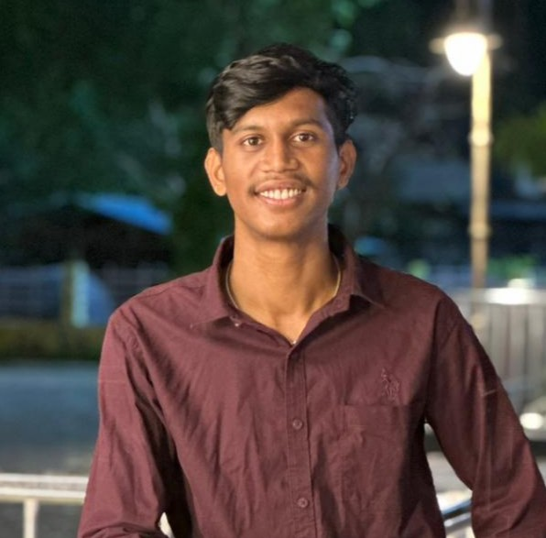

SULABH HATHI
Frontend / Full Stack Developer
|React.js | JavaScript

CONTACT
kumarsulabh2003@gmail.com https://www.linkedin.com/in/sulabh-hathi933a512b5
github.com/Sulabh13
(+91) 62631-10540
Balaghat, Madhya Pradesh.

KEY SKILLS AND CHARACTERISTICS
- Web Development: HTML5, CSS3, JavaScript (ES6+), React.js, Full Stack Fundamentals)
- Programming Languages: Python (Basics), C, C++
- Frontend Tools: Tailwind CSS, Responsive Web Design, Component Based UI
- Productivity Tools: MS Word, Excel, PowerPoint
- Version Control: Git & GitHub

ACTIVITIES AND INTERESTS
- Content creation & writing
- Cricket
- Chess
- Gaming
- Travel

PROFILE
Full Stack Developer with strong expertise in React.js, JavaScript, HTML, CSS, and modern frontend frameworks. Experienced in building responsive, user-friendly web applications and integrating REST APIs with backend services. Proficient in MySQL, basic backend development, and version control using Git. Passionate about clean code, performance optimization, and continuous learning.

EXPERIENCE
Full Stack | Frontend Developer & Technical Instructor Connect Shiksha Coding Classes, Balaghat (JAN 2025 – SEPT 2025)

- Designed and developed responsive web interfaces using HTML, CSS, JavaScript, and modern frontend practices.
- Built dynamic web applications with client-side logic, form handling, validation, and DOM manipulation.
- Worked with backend fundamentals, REST API concepts, and database interactions in project-based development.
- Worked with backend fundamentals, REST API concepts, and database interactions in project-based development.

Frontend | Full Stack Developer & Technical Trainer
Excellup Coding Classes, Balaghat (SEP 2025 - PRESENT)

- Developed and maintained frontend modules using JavaScript, HTML, CSS, Tailwind, and component-based design principles.
- Built and supported full stack web projects, including UI development, backend integration, APIs, and CRUD operations.
- Performed debugging, performance optimization, and basic project planning for web applications.
- Managed Git-based version control and collaborative development workflows.

EDUCATION

BACHELOR OF COMPUTER APPLICATIONS
Makhan Lal Chaturvedi University, Balaghat (AUG 2022 - PRESENT)

HIGHER SECONDARY EDUCATION
Madhya Pradesh Board, Balaghat (JULY 2021 - APRIL 2022)

DIPLOMA & CERTIFICATIONS
Trust and Security with Google Cloud
Trust and Security with Google CloudIndia (Jan 2026)

WEB DEVELOPMENT CERTIFICATION
Connect Shiksha Coding Institute, Balaghat, India (SEPT 2024 - FEB 2025)

